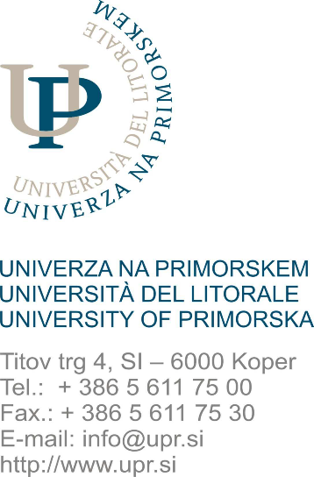
UNIVERZA NA PRIMORSKEM
UNIVERSITA DEL LITORALE / UNIVERSITY OF PRIMORSKA

FAKULTETA ZA MATEMATIKO, NARAVOSLOVJE IN INFORMACIJSKE TEHNOLOGIJE
FACOLTA DI SCIENZE MATEMATICHE NATURALI E TECNOLOGIE INFORMATICHE
FACULTY OF MATHEMATICS, NATURAL SCIENCES AND INFORMATION TECHNOLOGIES
Glagoljaška 8, SI – 6000 Koper
Tel.: (+386 5) 611 75 70
Fax: (+386 5) 611 75 71
www.famnit.upr.si
info@famnit.upr.si

APPLICATION FORM FOR THE RECOGNITION OF
UP FAMNIT OBLIGATIONS PERFORMED ABROAD

Student name/surname: __________________________________, enrolment number: ____________,
Study program (name and cycle of the study program):
_____________________________________________________________________________________,
Study year: ____________________, enrolment type (choose): first / repeated, I completed a study
exchange abroad from__________________ to _________________ at the following institution
(name and country of host institution):
_____________________________________________________________________________________.

I am kindly requesting the UP FAMNIT Committee for Study and Student Affairs for the recognition of completed study obligations abroad within the enrolled study program at UP FAMNIT.

Student signature: ______________________________________
Date: ____________________

Mandatory attachments:
- Learning Agreement and any amendments to the Learning Agreement,
- Transcript of Records from the host institution,
- descriptions of completed study obligations.

