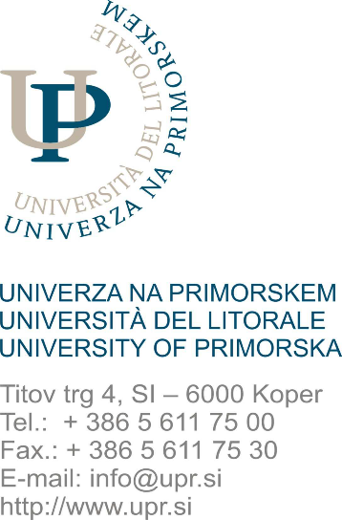
UNIVERZA NA PRIMORSKEM
UNIVERSITA DEL LITORALE / UNIVERSITY OF PRIMORSKA

FAKULTETA ZA MATEMATIKO, NARAVOSLOVJE IN INFORMACIJSKE TEHNOLOGIJE
FACOLTA DI SCIENZE MATEMATICHE NATURALI E TECNOLOGIE INFORMATICHE
FACULTY OF MATHEMATICS, NATURAL SCIENCES AND INFORMATION TECHNOLOGIES
Glagoljaška 8, SI – 6000 Koper
Tel.: (+386 5) 611 75 70
Fax: (+386 5) 611 75 71
www.famnit.upr.si
info@famnit.upr.si

APPLICATION FORM FOR THE CONCLUSION OF AND AMENDMENTS TO
THE LEARNING AGREEMENT FOR THE ERASMUS STUDY EXCHANGE

The signed form Application Form for the Conclusion of and Amendments to the Learning Agreement for the Erasmus Study Exchange is a condition for the signing of the Learning Agreement for students wishing to participate in an international exchange program. The student, in cooperation with the coordinator of the study program, fills in the form, obtains the signature of the Course Leader of compulsory courses (if necessary) and then submits the form to the UP FAMNIT Student Services.

STUDENT INFORMATION:

Name and Surname: ___________________________________, enrolment number: ____________,

Study program (name and cycle of the study program):
___________________________________________________________________________________,

Study year: _____________, enrolment type (choose): first / repeated.

PLANNED EXCHANGE INFORMATION:
Period of planned exchange abroad:

Study year: _____________, expectedly from (date) _______________ to __________________

Host institution (indicate the name of the university and the country of your exchange):

_________________________________________________________________________________

During the exchange, the student will perform study obligations that are equivalent to study obligations of the enrolled study program at UP FAMNIT (fill in the table below):

No. | Course name on the host institution | ECTS | Amendment to the Agreement |  | Equivalent course  on UP FAMNIT – type of obligation: | Name of equivalent course on UP FAMNIT: | ECTS | Recognition of a performed obligation (fully recognized / partially recognized) | Signature of the coordinator or  leader of a compulsory course
No. | Course name on the host institution | ECTS | Added Course | Deleted Course

Instructions:
In case of changes in the concluded Learning Agreement, indicate whether the specified course is added or deleted to the concluded Learning Agreement. If the course is deleted, it is not necessary to fill in the columns bound to the recognition of obligations to UP FAMNIT.
2 Type of obligation: compulsory course, internal elective course, external elective course, course outside the program.
3 Name of the equivalent course at UP FAMNIT: if it is a comparable course within the enrolled study program UP FAMNIT, it is necessary to write the name of the course.

Student signature: ______________________________________
Date: ____________________

FILLED OUT BY THE COORDINATOR (the student requests for the coordinator’s signature)
I, undersigned ___________________________________________________________ confirm, that the stated study obligations to be completed abroad by the student and the recognition of study obligations in the enrolled study program UP FAMNIT are appropriate.
In _______________, on _____________ Coordinator Signature: _______________________

FILLED OUT BY THE STUDENT SERVICES
We confirm, that the study obligations to be completed abroad by the student and the recognition of study obligations in the enrolled study program UP FAMNIT are appropriate.
In Koper, on _____________________ Signature: ____________________________________

